* Ocular Biometrics
  + The eye and its immediate surroundings
  + Consists of iris, sclera, eyelids, eyelashes, eyebrow, skin texture, etc.
* Color Iris
  + Iris is the annular region of the eye bounded by the pupil and the sclera
  + Visual texture of the iris stabilizes during the first two years of life and carries distinctive information useful for recognition
  + Each iris is believed to be unique; even irides of identical twins have been observed to be different
* Iris Texture
  + The iris exhibits a very rich texture consisting of “pectinate ligaments adhering into a tangled mesh revealing striations, ciliary processes, crypts, rings, furrows, a corona, sometimes freckles, vasculature, and other features”
* Primary Function of the Iris
  + The primary function of the iris is to regulate the amount of light entering the eye by dilating or contracting a small opening in it called the pupil.
  + The iris contracts the pupil when the ambient illumination is high and dates it when the illumination is low.
* Impact of Dilation Drugs
  + Hamming distance between iris codes
    - 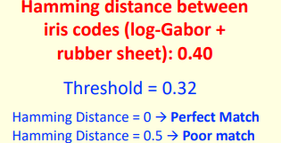
  + Pupil dilation drugs (mydriatic agents) may be used by an adversary to mask their identity from an iris recognition system
  + FNMR increases when matching iris images with large differences in pupil size
  + 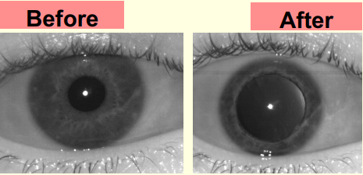
* 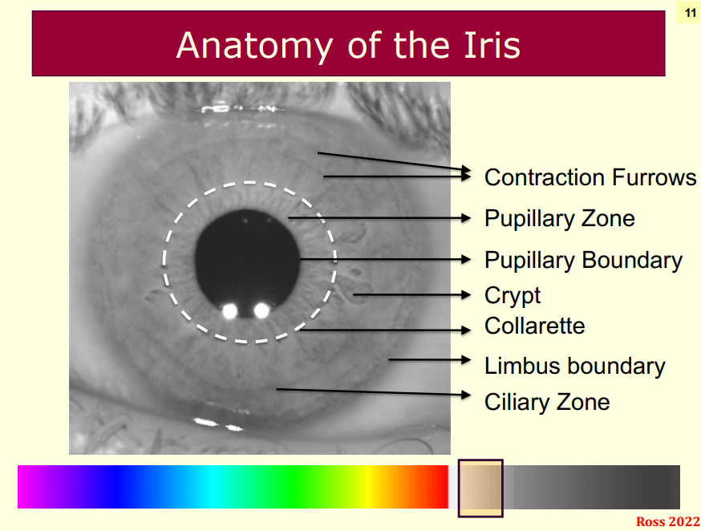
* WHY NIR - Near Infrared - Optics?
  + Dark-color Iris: The textural details of dark-colored irides (majority of the world population) are more evident in the NIR channel than in the red, green, or blue channels.
  + Non-intrusive: NIR light cannot be perceived by the human eye. This ensures that the image acquisition process is non-intrusive, even when the eye is required to be in close proximity to the sensor and the NIR light source.
* Structure of the iris
  + The posterior layer at the back, which is two cells thick, contains heavily pigmented epithelial cells, making it impenetrable to light.
  + The muscle layer above it consists of the sphincter (circle-like) and dilator (spoke-like) muscles that contract and dilate the pupil.
  + The stromal layer, located above the muscles, is made up of collagenous connective tissue (arranged in an arch-like configuration) and blood vessels (arranged along the radial direction).
  + The anterior border layer is the foremost layer and has an increased density of chromatophores (i.e. pigment containing cells) compared to the stromal layer.

